***Pc bottle***

***A PC (Polycarbonate) bottle is typically made from a durable, clear, and lightweight plastic material known for its high impact resistance and strength***.

* **Basic 500ml to 1L PC Bottle**:
* 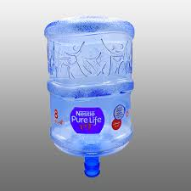**Price range**: PKR 300 to PKR 700
* **Sports or Travel PC Bottles (1L to 2L)**:
* **Price range**: PKR 700 to PKR 1,500
* **Baby Bottles (PC material)**:
* **Price range**: PKR 500 to PKR 2,000**Branded PC Bottles (e.g., Tupperware, Nalgene, etc.)**:**Price range**: PKR 1,500 to PKR 3,500